**Project Report**

Big Mountain Resort (BMT) is a large ski resort located in Montana. Every ski season 350,000 visitors enjoys the resort’s large infrastructure of lifts to access 105 trails, a 2,353 vertical drop, and views to national parks and forests. Historically price strategy has been based on market segmentation. Currently, the resort’s price for week and weekend tickets is USD 81.00. However, recently management wants adopt a data-driven pricing strategy, optimize infrastructure usage and protect profit margins.

Our data exploratory analysis (DEA) produced several insights into the relationship between ticket price and resort features. Fig. 1 shows a correlation heat map between resort features.

Fig. 1 – Correlation heat map between ski resort data variables.

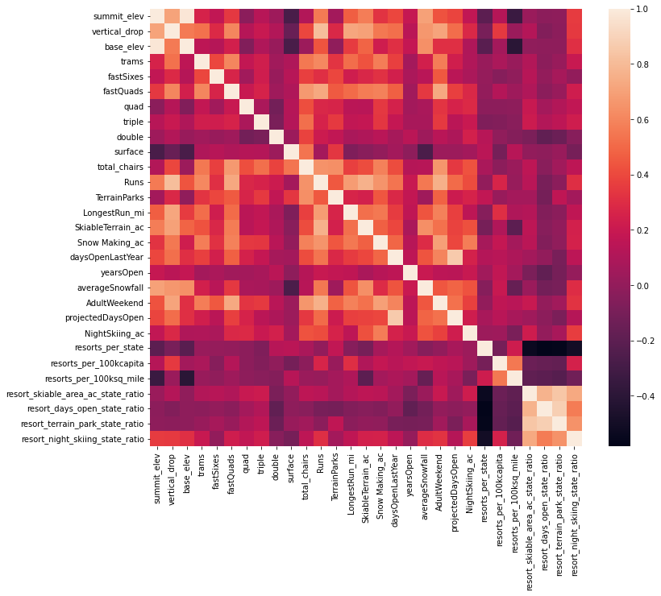

The correlation heat map shows that adult weekend ticket prices has a high positive correlation with vertical drop, fast quads, number of runs, snow making area, projected days open, days open, and total number of chairs. Insights from heat map lead to a closer analysis through scatter plots between ticket prices and resort variables.

Fig. 2 – Scatter plot between ticket price and ski resort features.

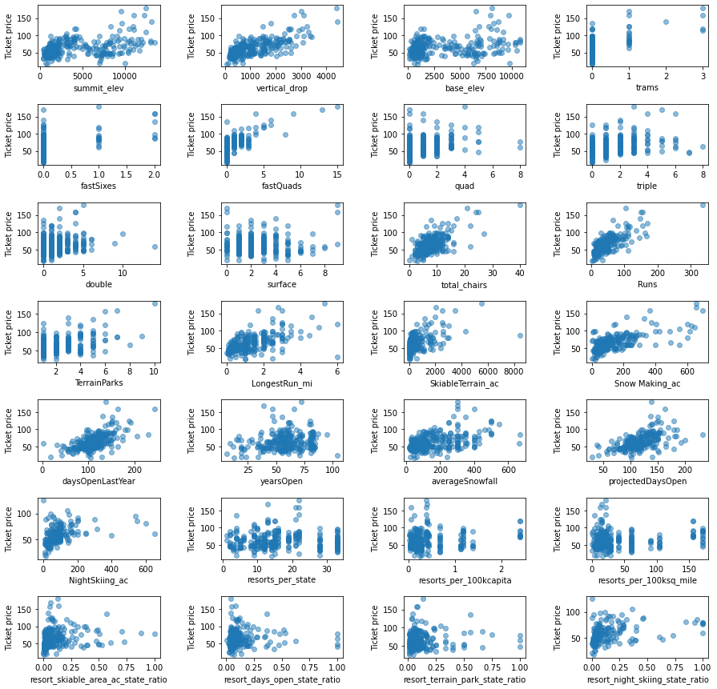

The scatter plot shows strong positive linear relationship between ticket prices and Vertical drop, trans, fast quads, total chair, runs, longest run, skiable terrain, snow making, days open, and night skiing. However, several of these relationships seem to drop off, suggesting diminishing returns on several of the resources.

Expanding from EDA insights, we successfully developed, trained, and optimized a ticket-pricing model based on BMT’s market segmentation by applying regression and random forest regression models. Furthermore, we used appropriate cross validation to avoid over fitting out model to the training data, therefore we are confident in the model estimates.

Random forest regression (RFR) minimized our loss function, which was based on mean absolute error metric. RFR model generated important insight relevant for BMT financial and operational management. First, our data-driven modeling shows that the marketplace would be able to support a higher price based on BMR's current features. The model estimated a feature-based price of USD 95.87.

Second, our pricing model identified fast quads, number of runs, snow making capability, and vertical drop as the most important feature in predicting ticket price.

Third, modeling scenarios show increasing snow making area by 2 acres or increasing the longest run by .2 miles have no effect on estimated ticket price. However, closing down 1 run doesn’t have an effect on price and closing 3, 4 or 5 runs have the same effect on ticket price. In addition, a scenario where the resort adds a run, increases the vertical drop by 150 feet, and installs an additional chair lift support an increase of ticket price by USD 8.67.

This project can be expanded in several promising ways; First, data on visitors should be collected and analyzed to understand BMR’s customers profile and needs. Second, increase operating days would help dilute fixed cost, thus leveraging the resort location to open in summer should be analyzed.